### Semester Two Examination, 2020

### Question/Answer booklet

# MATHEMATICS SPECIALIST

**UNITs 3 & 4**

## Section Two:

## Calculator-assumed

|  |
| --- |
|  |

Your Name

Your Teacher’s Name

## Time allowed for this section

Reading time before commencing work: ten minutes

Working time: one hundred minutes

## Materials required/recommended for this section

***To be provided by the supervisor***

This Question/Answer booklet

Formula sheet (retained from Section One)

***To be provided by the candidate***

Standard items: pens (blue/black preferred), pencils (including coloured), sharpener, correction fluid/tape, eraser, ruler, highlighters

Special items: drawing instruments, templates, notes on two unfolded sheets of A4 paper, and up to three calculators approved for use in this examination

## Important note to candidates

No other items may be taken into the examination room. It is **your** responsibility to ensure that you do not have any unauthorised material. If you have any unauthorised material with you, hand it to the supervisor **before** reading any further.

|  |  |  |  |  |  |
| --- | --- | --- | --- | --- | --- |
| **Question** | **Marks** | **Max** | **Question** | **Marks** | **Max** |
| **8** |  | **8 8** | **15** |  | **7** |
| **9** |  | **9 7** | **16** |  | **5** |
| **10** |  | **16** | **17** |  | **6** |
| **11** |  | **8** | **18** |  | **10** |
| **12** |  | **10** |  |  |  |
| **13** |  | **9** |  |  |  |
| **14** |  | **9** |  |

**Structure of this paper**

|  |  |  |  |  |  |
| --- | --- | --- | --- | --- | --- |
| Section | Number of questions available | Number of questions to be answered | Working time (minutes) | Marks available | Percentage of examination |
| Section One:  Calculator-free | 7 | 7 | 50 | 50 | 34 |
| Section Two:  Calculator-assumed | 11 | 11 | 100 | 89 | 66 |
|  |  |  |  | **Total** | 100 |

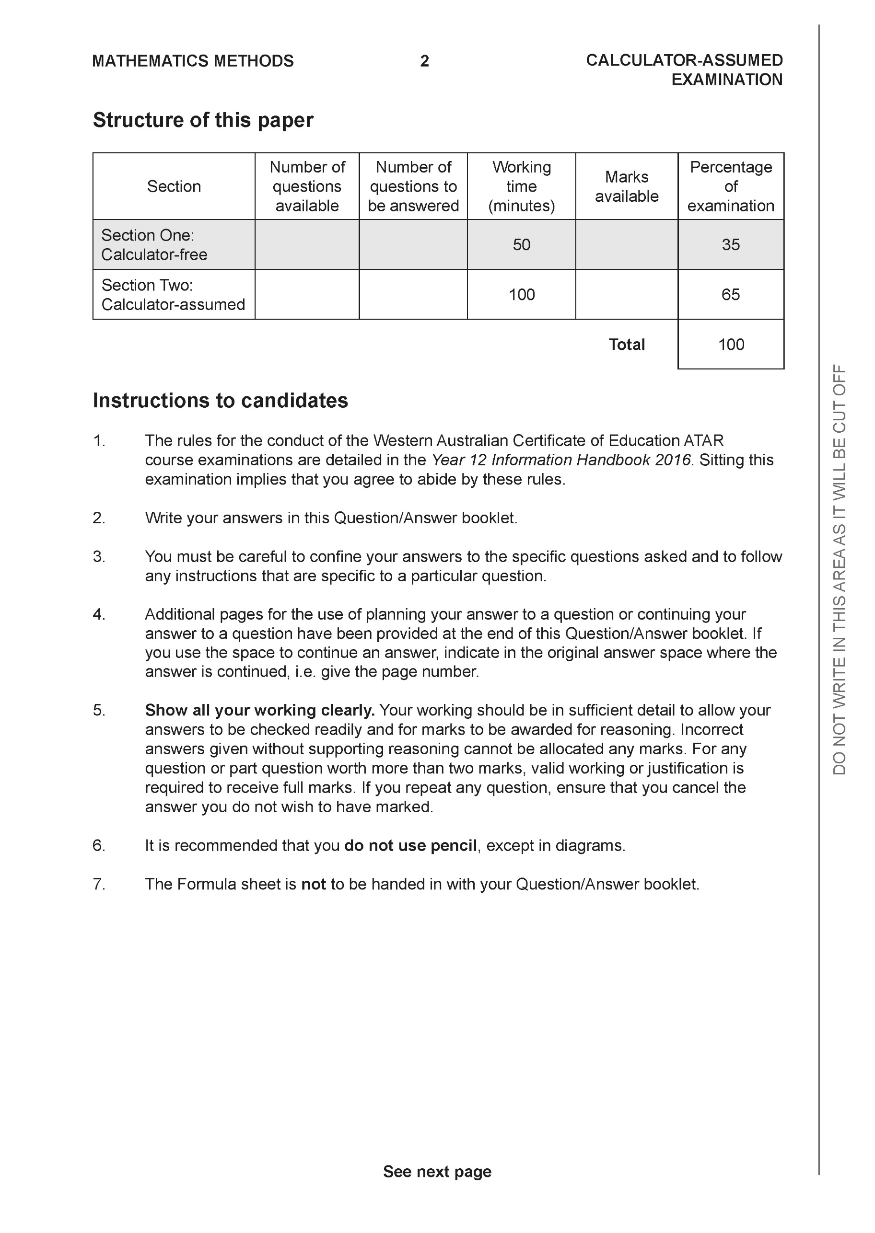

**Section Two: Calculator-assumed (89 Marks)**

This section has **11** questions. Answer **all** questions. Write your answers in the spaces provided.

Spare pages are included at the end of this booklet. They can be used for planning your responses and/or as additional space if required to continue an answer.

● Planning: If you use the spare pages for planning, indicate this clearly at the top of the page.

● Continuing an answer: If you need to use the space to continue an answer, indicate in the original answer space where the answer is continued, i.e. give the page number. Fill in the number of the question that you are continuing to answer at the top of the page.

Working time: 100 minutes.

**Question 8 (8 marks)**

The sketch of the locus  is shown below.

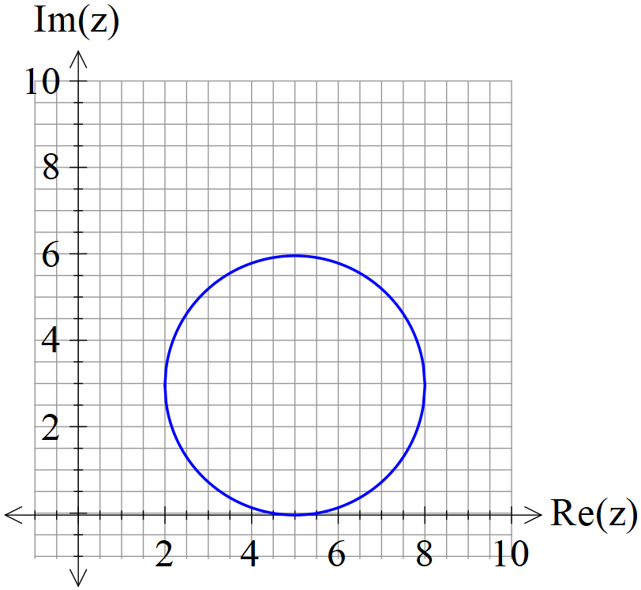

1. Determine an equation for . (3 marks)
2. Determine the maximum value of  (3 marks)
3. State the value of from the locus above that also satisfy 

(2 marks)

**Question 9 (7 marks)**

The slope field  is plotted below.

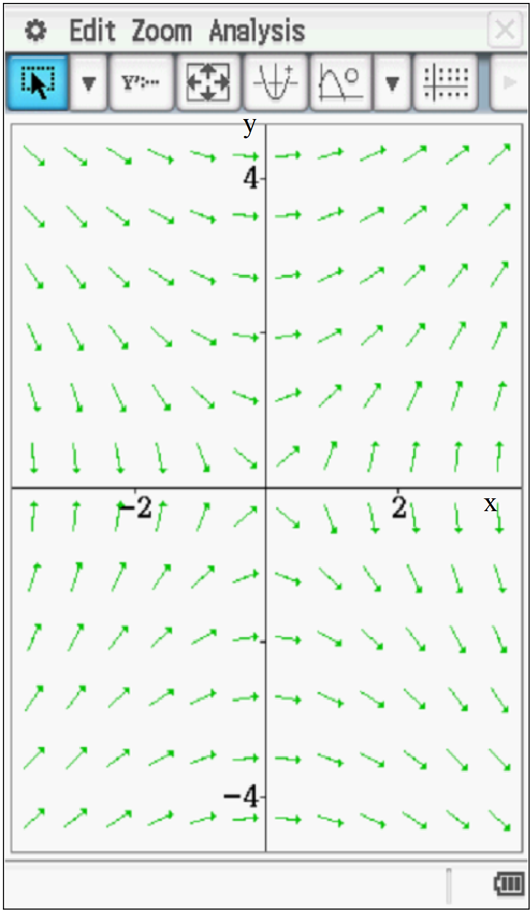

(a) Determine the value of the slope field at point A(2,2). (2 marks)

(b) On the diagram above, sketch the solution curve that passes through A(2,2). (2 marks)

(c) Determine the equation of the solution curve that passes through A(2,2). (3 marks)

**Question 10 (10 marks)**

Consider .

1. Determine all roots to the above equation in polar form  with .

(4 marks)

1. Plot all roots on the diagram below. (3 marks)

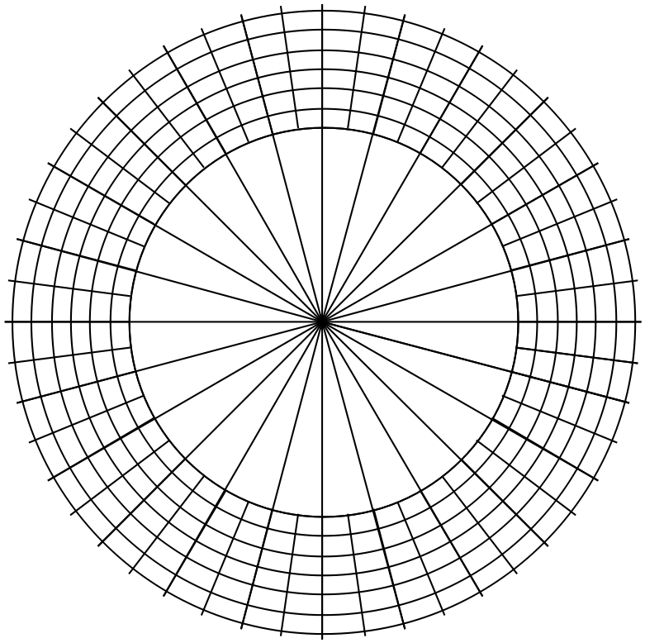

1. Joining these roots will form a polygon, determine the area of this polygon.

(3 marks)

**Question 11 (8 marks)**

Consider the path of a stunt airplane that travels at a constant height according to the following position vector  km at  hours.

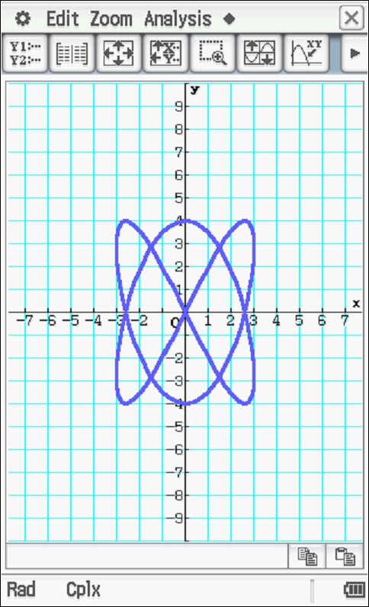

1. Plot the starting point of the plane on the above diagram showing the direction of motion. (2 marks)
2. Determine the initial acceleration. (3 marks)
3. State an expression for the distance travelled in one circuit of the motion, do not evaluate this expression. (3 marks)

**Question 12 (10 marks)**

The length of time in minutes that a patient spends with a dentist is normally distributed with a mean of 45 minutes and a population standard deviation of 8 minutes.

A sample of 50 patients is taken as a study of the habits at a particular dental practice.

1. State the approximate sample mean length distribution for the 50 patients. (3 marks)
2. Determine the probability that the sample mean length will be less than 35 minutes.

(2 marks)

1. Suppose that less than 50 patients were chosen for the sample size, what would happen to the answer in (b) above, do not recalculate. Explain (2 marks)
2. It is desired that the probability that the sample mean length time between 43.5 minutes and 46.5 minutes is at least 55%. Determine the minimum sample size for this to occur.

(3 marks)

**Question 13 (9 marks)**

The time taken for a WACE marker to mark a Methods exam paper has a mean of 55 minutes.

A sample of  WACE markers was obtained and the **sample mean** standard deviation was

found to be 12 minutes.

1. Determine a 95% confidence interval for the population mean of marking time to the nearest 0.01 minutes. (3 marks)
2. If a sample of  WACE markers was obtained from the same population, determine the standard deviation of this new sample mean. (2 marks)
3. Which of the two samples above have a greater precision for determining the true population mean . Explain. (2 marks)
4. A 95% confidence interval is determined for the sample of  WACE markers. When compared to the confidence interval calculated in (a) above, which interval contains the true value of ? Explain. (2 marks)

**Question 14 (9 marks)**

Consider the sphere given by the following cartesian equation .

1. Determine the vector equation of this sphere. (3 marks)

Consider a second sphere  given by .

1. Determine the distance of the centre of from the plane . (3 marks)
2. Is the line  a tangent to the sphere ? Explain. (3 marks)

**Question 15 (7 marks)**

1. By using integration and partial fractions, show that the solution to the differential equation  is  where  are constants for time  hours. ( initial value of P) (4 marks)

Q15 cont-

1. Let  represent the number of bacteria cells present on a laboratory tray at time  hours. The initial number being 300 cells and the rate of change given by

.

Determine the approximate number of bacteria cells after 8 hours. (3 marks)

**Question 16 (5 marks)**

Consider person B ridding on a merry go round at an angular speed of 12 rad/sec clockwise and person A moving towards the centre of the merry go round at a speed of 3 m/sec. Initially person A is 25 m from the centre and the angle for person B is . Determine the initial rate of change of the distance between persons A & B.

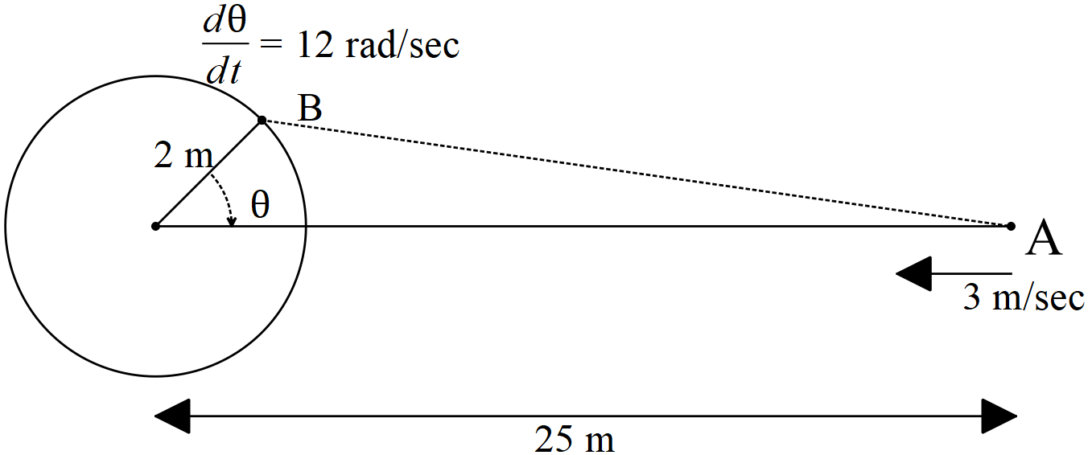

**Question 17 (6 marks)**

Consider the following two planes;



1. Determine the distance between the two planes. (4 marks)
2. Consider the point , derive an expression for the distance of this point to the plane  above. (2 marks)

**Question 18 (10 marks)**

Consider an object moving with motion  where  is the displacement from the origin in metres at time  seconds. The initial displacement is 5 metres given that the velocity is zero when metres.

1. Determine the displacement at any time  seconds. (2 marks)
2. Determine the percentage of time that the distance from the origin is between 2 and 7 metres. (4 marks)
3. Show by **using integration** that for  the following can be derived  where  equals the amplitude. (4 marks)

Additional working space

Question number:

**Acknowledgements**